 | Appendix 8
 | Format for Mandatory Disclosure
 | Mandatory Disclosure | 28-04-17
1 | AICTE Permanent ID | 1-2875458759
 | Date & Period of last approval | 20-04-2017 Period of Approval:2017-18
2 | Name of Institution | Pakur Polytechnic (Established by Govt. of Jharkhand and Run & Managed by Cybobhubaneswar Educational foundation)
 | Address of Institution | Behind New DC Combined Building, Pakur
 | City & PIN code | Pakur-816107
 | State/UT | Jharkhand
 |  | 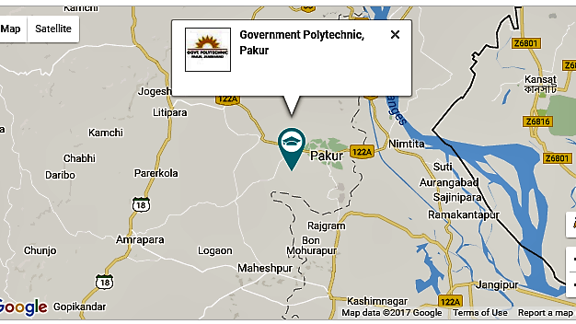
 | Phone number with STD code | 07484840028/29
 | FAX number with STD code | 0612-2270241 (Tele. Fax)
 | Office hours at the Institution | 0900 - 0500 hrs.
 | Academic hours at the Institution | 0900 - 0500 hrs.
 | Email | govtpolytechnicpakur@gmail.com
 | Website | pakurpolytechnic.ac.in
 | Nearest Railway Station (dist. In Km) | Pakur (6 Km)
 | Nearest Airport (dist. In Km) | Ranchi (390 Km)
3 | Type of Institution | Unaided - Private
 | Category (1) of the Institution | Non-Minority
 | Category (2) of the Institution | Co-Ed
4 | Name of the organization running the Institution | Cybobhubaneswar Educational foundation
 | Type of Organization | Company U/S 8 of Companies Act 2013
 | Address of the organization | 2nd Floor, Cybotech Tower, Boring Patliputra Road, Patna-13, Bihar
 | Registered with | Ministry of Corporate Affairs
 | Registration date | 22-02-16
 | Website of the organization | pakurpolytechnic.ac.in
5 | Name of the affiliating body | SBTE, Jharkhand
 | Address | SirkhaToli, Science & Technology Campus, Namkum-Tupudana Road, Ranchi, Jharkhand-8340101
 | Website | sbtejharkhand.nic.in
 | Latest affiliation period | 2016-17
6 | Name of Principal | Prof. P. K. Das
 | Exact Designation | Principal
 | Phone number with STD code | 7484840029
 | FAX number with STD code | 0612-2270241 (Tele. FAX)
 | Email | pkdasme@gmail.com
 | Highest Degree | Ph.D.
 | Field of specialization | Mechanical
7 | Governing Board Members | Give details of all members with educational qualification and other credentials

Pakur Polytechnic, Pakur, Jharkhand
Board of Governors
Name | Designation | Qualification | Other Credentials
Mr. Abhijit Kumar | Director | BSc., PGDM (MBA), BA(LLB) | Founder Member, Cybobhubaneswar Educational foundation
Mr. Amiya Ranjan Badajena | Director | MBA | Founder Member, Cybobhubaneswar Educational foundation
Mrs. Renuka Yashaswee | Member | B.Sc. (From Science College, Patna), BIT, MCA MBA [HR Spec.], MTech(IT) and Pursuing Ph.D. in Management Studies
Mrs. Rajshree Baliar Singh | Member | Graduate

 | Frequency of meetings & date of last meeting | Thrice a year & date of last meeting: 31st March 2017

8 | Academic Advisory Body

Pakur Polytechnic, Pakur, Jharkhand
Academic Advisory
Name | Department/University
Prof. J. Jha | Ex-Director, BIT - Sindri  Ex-Director, BIT- Mesra
Prof. S. N. Sinha | Ex-Director, MNNIT Engineering College, Allahabad  Ex-Director, NIT-Jamshedpur
Shri Ravi Shankar Kumar | Advocate (Supreme Court of India)

 | Frequency of meetings & date of last meeting | Twice a year & date of last meeting: 9th July 2016

